Half Yearly Progress Report on Research Work carried out from 28.03.2012 to 27.09.2012
Name and address of the candidate : P. Mohandass
Reg. No. P8851
PG and Research Dept. of Chemistry
Saraswathi Narayanan College
Madurai-22.

Occupation if any and address : Associate Professor of Chemistry
Saraswathi Narayanan College
Madurai-22.

Name, designation and address of the : Dr. K. Radhakrishnan
Guide Associate Professor of Chemistry
Saraswathi Narayanan College
Madurai-22.

College where the candidate carried : PG and Research Dept. of Chemistry
out the research Saraswathi Narayanan College
Madurai-22.

Whether the candidate has paid annual
Research fee (mention amount, date of : No
remittance, place of bank, etc.)

Detailed one page report on the progress : Separate sheet Attached
of research work carried out by the
candidate (attach separate sheet)

Remark, if any by the guide : Nil

Signature of the candidate Signature of the research supervisor

Half Yearly Progress Report on Research Work carried out from 28.03.2012 to 27.09.2012

Preparation of 4′-substituted (E)-1-(furan-2-yl)-3-phenylprop-2-ene-1-one.
(E)-1-(Furan-2-yl)-3-phenylprop-2-ene-1-one and its 4′-substituted compounds were prepared by the following procedure.
The mixture of the calculated amount of the pure 2-acetylfuran (0.55g ~ 0.005 moles) in cold ethanol and 10% solution of sodium hydroxide (catalytic amount) was cooled in a water bath to 0º C. To this mixture pure benzaldehyde (0.583 g ~ 0.0055 moles) in cold ethanol was added drop by drop for 30 minutes. The reaction mixture stirred for 2 hours. Then it was kept in the refrigerator for overnight. The precipitated solid was collected and recrystallized using ethanol-chloroform (10:1) mixture. All the substituted compounds were prepared by using the above procedure.

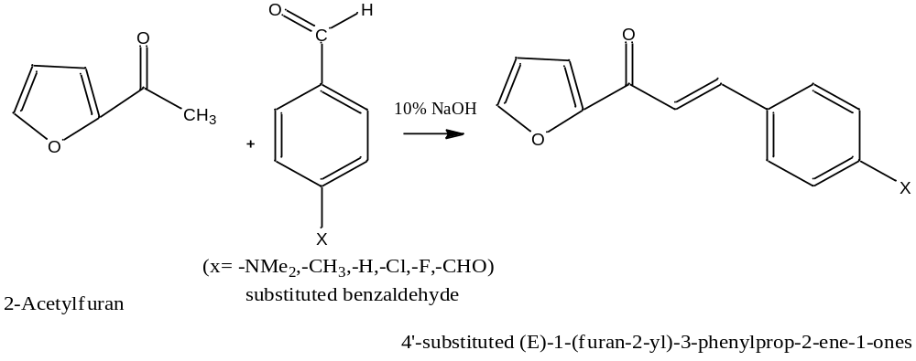

Signature of the research supervisor

